Lab No 9
Downloading Installation process of
PSpice Student version 9.1
Objectives:
We want to learn how to install "PSpice Student Version 9.1".
we want to learn different steps for its installation.
Install "PSpice" for making/creating electronic circuits and electric board diagram.
we install it for future use.
Procedure:
Downloading

First of all we download the "PSpice student version 9.1" from the following links;
- http://Pspice-student.informer.com


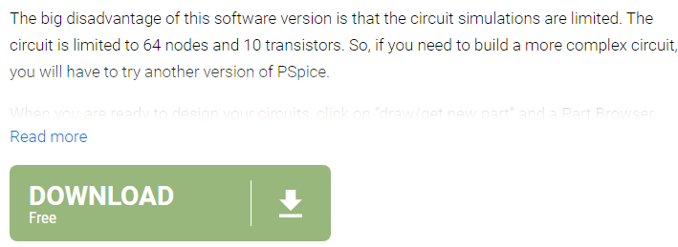

- http://en.freedownloadmanager.org/windows-PC/pspice- student-FREE.html



- http://on.freedownloadmanager.org/windows-PC/pspice- student-FREE.html

OR
Simply search "PSpice student version 9.1" on any browser and open the website of Pspice and download it easily.
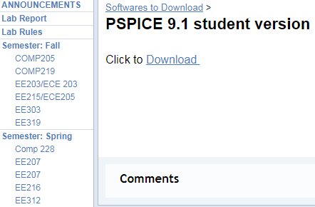

Click on Download option and download the software easily.
Installation
After downloading it unzip the file and click ok. Setup of PSpice will apear or show in your PC c:\ drive such as;
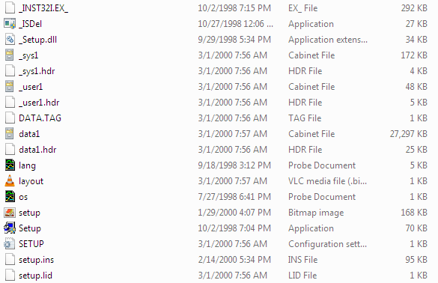

Now click on setup of 70 KB and run as administrator to install the software of PSpice such as;

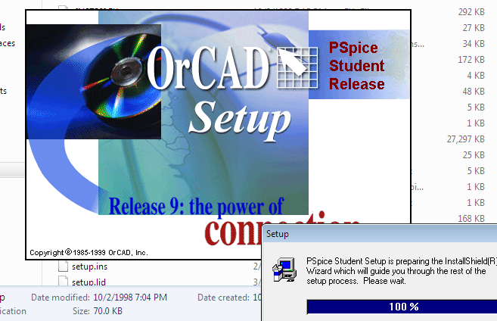
After this the warning option will appear on screan because this software is from unknown source .Click on Yes and proceed the process s
Click on Next button the other menu will open . Click on Next the Button and then proceed the installation when the installation of PSpice will complete the notification of OK will appear then click on OK and the notification will disappear now your installation will complete.
Now click on start menu and search PSpice your installed software will appear on it click and open it and use it for your circuits , boards drawing purposes.

